# Using the Twitter API

Before you can make use of the Twitter API it is necessary to obtain a set of four keys from the Twitter website. The following instructions will guide you through this process. The keys are all alphanumeric text and can be stored in a simple text file.

It is assumed that you already have a Twitter account.

paste <https://dev.twitter.com/> in your browser.



1. Click on the Apply button (sign in to twitter if you need to).
2. From the apply page select the ‘Get started with standard access’ option

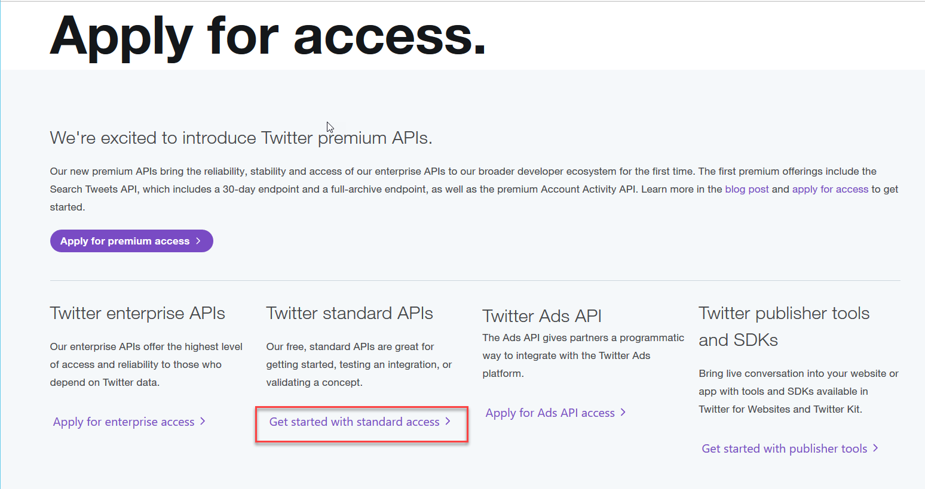

1. From here follow the instructions for creating an app.

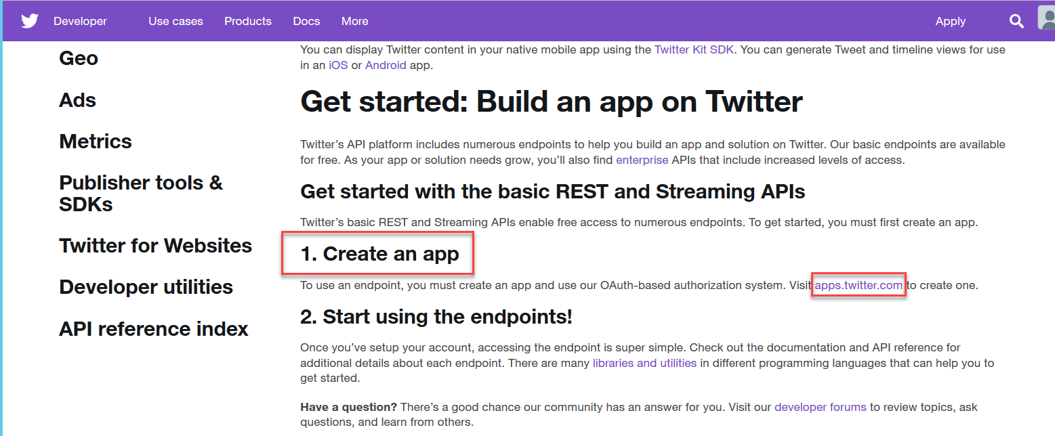

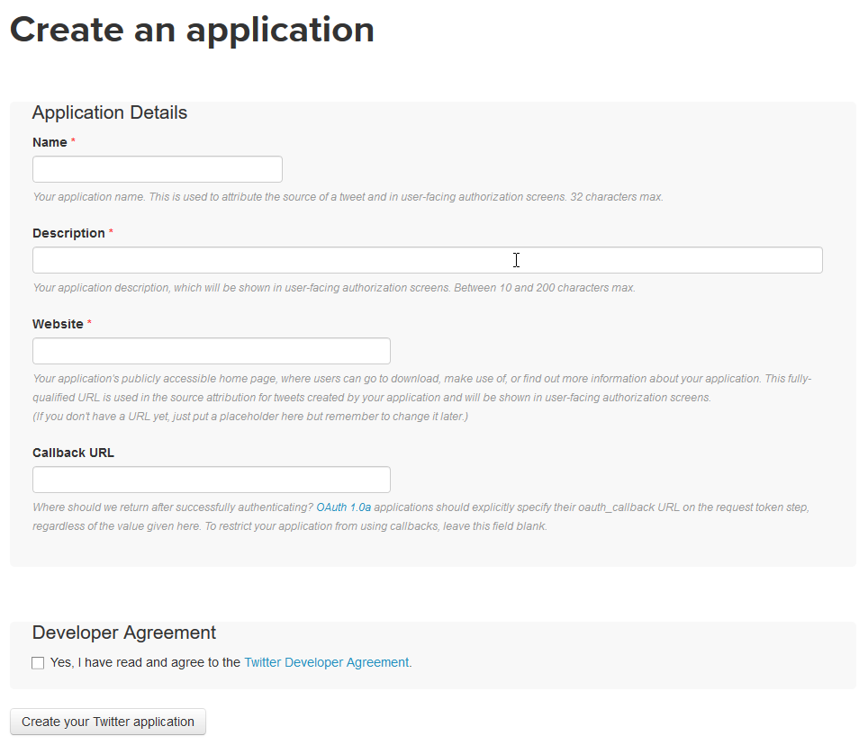

1. You need to provide a name, description and Website name for your application. The website name can be fictitious like ‘http://demo.website.com’. Tick the checkbox to show that you have read the agreement and then click the ‘Create your Twitter application’ button.
2. If all is well, the next page will be displayed. About half way down on this page under Application settings, click on manage keys and access tokens.

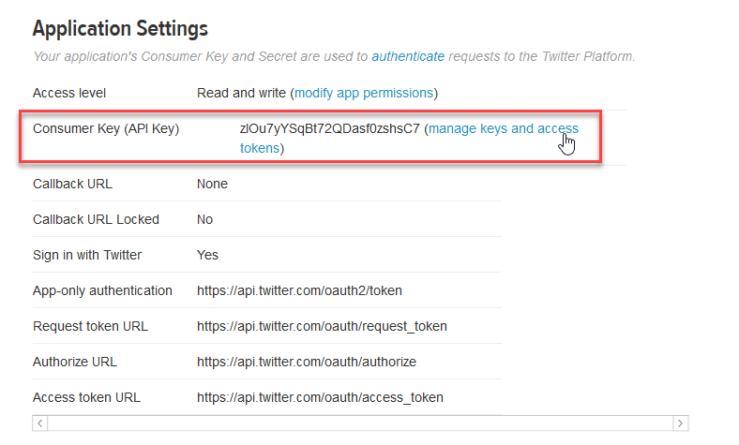

1. On the applications setting page the consumer key and consumer secret will be shown, these are two of the keys you will requie. At the bottom of the page there will be a ‘create my access token’ button which you should click

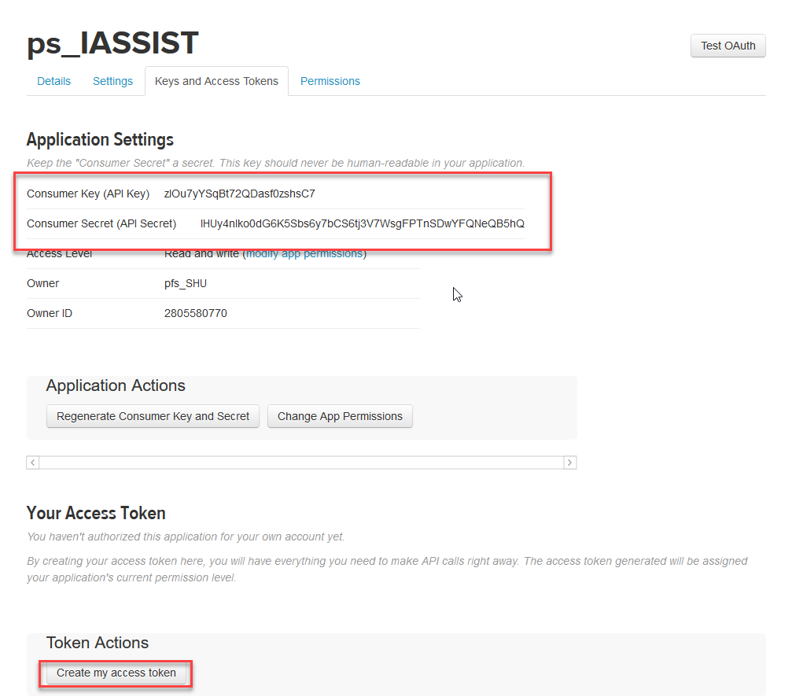

1. The screen will be updated to show your Access token and the Access Token Secret. These are the other two keys which you will require.

